**Fishing Fisher's Flower Figures - An exploration of the Iris Dataset**

**Helen** O’Shea

**Galway Mayo Institute of Technology**

Table of Contents

**Fishing Fisher's Flower Figures - An exploration of the Iris Dataset** 1

**Abstract** 3

**Introduction** 4

**Method** 7

**Results** 8

**Discussion** 36

**References** 39

**Appendix** 40

**Abstract**

This report explores the Iris dataset using data analytics techniques. The Iris data consists of 50 samples from three species of Iris namely Iris Setosa, Iris Virgincia and Iris Versicolor. It consisted of measures of the flowers sepal and petals’ length and width in centimetres. The dataset was analysed using three approaches, descriptive statistics, graphical visualisations and inferential statistics. The method used was statistical analysis using python and python modules. Results showed clear differences between one species and the other two when the data was unlabelled and a third cluster of data when all Iris species were labelled.

**Introduction**

The Iris data set, also known as Fisher or Anderson’s Iris flower data set, was popularised by the statistician Ronald Fisher in his 1936 paper “The use of multiple measurements in taxonomic problems” (Fisher 1936). It was collected by the American botanist, Edgar Anderson in 1935 yet remained unpublished till Fisher published it in his 1936 paper (ibid). Anderson’s data consisted of fifty samples each, from the three species of Iris, Iris Setosa, Iris Virginica and Iris Versicolor. Two of the species, Iris Virginica and Iris Setosa, were sampled from the same region while the Iris Versicolor was sourced elsewhere.

The data was used by Fisher to illustrate discriminant functions (ibid). In addition Fisher extended this method to investigate Randolph’s hypothesis that the third species, Iris Versicolor, was a hybrid of the Iris Virginica and Setosa species (ibid). Anderson recorded five measures, the species type and its corresponding length and width of its petals and sepals. Measures were taken in centimetres (cm). The petals are the inner flower while the sepals protect the emerging flower on the outer part of the plant structures as seen in figure 1. Hence plant sepals are present for a greater time span than the petals.

*Figure 1: Sepal and Petal of the Iris Versicolor*

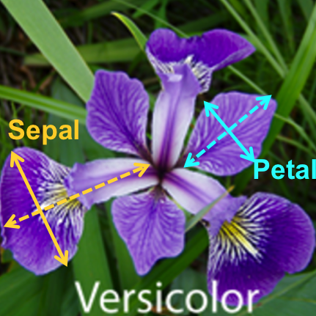

Figure 2, figure 3 and figure 4 are pictures of the flowering Iris Setosa, Iris Virginica and Iris Versicolor respectively.

*Figure 2: Iris Setosa*

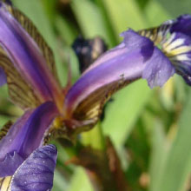

*Figure 3: Iris Virginica*

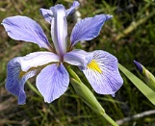

*Figure 4:* *Iris Versicolor*

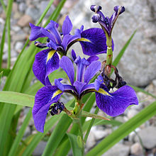

Thus the data Anderson collected consisted of 150 samples of Iris spanning 5 dimensions; namely 4 one dimensional measures in cm, sepal length (sepalL), sepal width (sepalW), petal length (petalL), petal width (petalW); And one categorical dimension of Iris species (name).

This project used the version of the Iris data hosted at UCI machine learning repository (Iris Data set, Iris Data, donated 1988). The UCI version contains two errors from Anderson’s original data which were not amended in the analysis (Bezdek, Keller et al., 1999). Both errors were the Iris Setosa samples (Iris Data, donated 1988).

Fisher’s analysis investigated if petal/sepal measurements alone could predict which species of Iris the sample came from (Fisher, 1936). This makes the data useful in many aspects of computer science. Other reasons the Iris data set was used include the following; The Iris data set is well known, and often cited. Iris Data Set (Donated, 1988) notes 99 citations with citations from as recently as 2005. The set has historical significance, as does Fisher, and is widely recognised in computer science. Fisher’s Iris data set is often used as a learning tool in data analytics, and artificial neural networks. The data is small enough to be manageable for beginners yet sufficiently challenging in what it can reveal. Its historical use means that there is a body of work and continuity based on it, which can be used as a benchmark to test program results and explore data analytic methods.

Fisher's analysis showed two main clusters, with the Iris Setosa petal and sepal measures being smaller than the Iris Virginica. Iris Versicolor was intermediate between the other two species with some overlap of measures with Iris Virginica (ibid). This separation into two groups is an example of unlabelled clustering. Once the samples are labelled by species then three clusters emerged. This project sought to replicate these findings and explore the data further with the more modern tools of computer science.

This project explored the Iris Data using the programming and scripting language Python Version 3.6. In addition GitHub was as the development platform for this project. Python is fast becoming the standard tool for data analysis. It is free and open source, unlike SPSS or SAS for example. It also has a more intuitive syntax than R for example. In addition Python has a wide selection of modules that can be used to investigate particular aspects of the data. For example the Pandas module offers data frame manipulation and table reading tools; NumPy offers numerical and scientific computing; Matplotlib extends NumPy to include plotting ability and Seaborn extends Matplotlib to allows statistical data to be visualised and Scipy has useful statistical tests.

This project aimed to explore the Iris data as hosted at UCI. Firstly descriptive data was calculated using Python. This included the maximum, minimum and mean of the petal and sepal measures for each of the species of Iris. Then various visualisations were produced to explore areas that might need further investigations. Finally introductory inferential statistics were investigated to explore if there was significant differences between the Iris species.

**Method**

This report produced descriptive, inferential and graphical visualisations of the Iris data set as hosted at UCI (Iris Data, Donated 1988).

#### Data

This project used a copy of the Iris dataset available from UCI (Data Set, Donated 1988). A sample of which can be viewed below in Table 1a. The full table is available in Table 1 (Appendix 1). The column headings are as follows; sepalL represents the sepal lengths, sepalW represents sepal widths, petal represents petal lengths, petalW represents petal widths and name represents the iris species, Iris-setosa, Iris-versicolor and Iris-virginica. All measures are in cm.

*Table 1a*

|  |  |  |  |  |  |
| --- | --- | --- | --- | --- | --- |
|  | sepalL | sepalW | petalL | petalW | name |
| 0 | 5.1 | 3.5 | 1.4 | 0.2 | Iris-setosa |
| 1 | 4.9 | 3.0 | 1.4 | 0.2 | Iris-setosa |
| 2 | 4.7 | 3.2 | 1.3 | 0.2 | Iris-setosa |
| 3 | 4.6 | 3.1 | 1.5 | 0.2 | Iris-setosa |
| 4 | 5.0 | 3.6 | 1.4 | 0.2 | Iris-setosa |
| 5 | 5.4 | 3.9 | 1.7 | 0.4 | Iris-setosa |
| 6 | 4.6 | 3.4 | 1.4 | 0.3 | Iris-setosa |
| 7 | 5.0 | 3.4 | 1.5 | 0.2 | Iris-setosa |
| 8 | 4.4 | 2.9 | 1.4 | 0.2 | Iris-setosa |
| 9 | 4.9 | 3.1 | 1.5 | 0.1 | Iris-setosa |

#### Apparatus and Materials

A computer with Python 3.6 software installed was used. An internet connection was required for conducting research. In addition the python modules, NumPy, Scipy, Pandas, Matplotlib and Seaborn were used. GitHub in conjunction with Visual Studio Code was used for program development.

#### Procedure

The data was downloaded from UCI Iris.csv (Data Set, Donated 1989) as a cvs file and stored in a local folder as /project /data/Iris.csv. The Python module Pandas was used to import the data as a dataframe and to perform initial descriptive analysis. Firstly the shape of the data was looked at. Then descriptive statistics were produced for each species of Iris (length/width ratios, mean, maximum and minimum values of the measures).

Then the data was explored using visualisation techniques including scatter plots, box plots and various density plots. The data was visualised using the NumPy extension modules Matplotlib and Seaborn. Scipy was also used.

Inferential statistics were computed using Student’s t-test for comparing two means from normal distribution and equal variances and Welch’s adaption of Student t-test when variances are unequal.

**Results**

#### *Descriptive statistics*

The descriptive statistics were taken by running the script project/pyscripts/desc.py. Results were saved in folder project/data/ with data from desc_se.csv shown in table 2; desc_vi shown in table 3 and desc_ve shown in table 4.

*Table 2: Iris Dataset descriptive statistics*

|  |  |  |  |  |
| --- | --- | --- | --- | --- |
| Iris cm | sepalL | sepalW | petalL | petalW |
| count | 150 | 150 | 150 | 150 |
| mean | 5.843 | 3.054 | 3.759 | 1.199 |
| std | 0.828 | 0.434 | 1.764 | 0.763 |
| min | 4.3 | 2 | 1 | 0.1 |
| 25% | 5.1 | 2.8 | 1.6 | 0.3 |
| 50% | 5.8 | 3 | 4.35 | 1.3 |
| 75% | 6.4 | 3.3 | 5.1 | 1.8 |
| max | 7.9 | 4.4 | 6.9 | 2.5 |

Table 2 shows that mean lengths are greater than widths for both sepals and petals. Sepal widths are slightly smaller than petal lengths, which had the largest spread of all the measures. The maximum values approximately double the minimum values except in with petal lengths. The data was grouped by species name and analysed further.

*Table 3:* *Iris Setosa descriptive statistics*

|  |  |  |  |  |
| --- | --- | --- | --- | --- |
| Setosa cm | sepalL | sepalW | petalL | petalW |
| count | 50 | 50 | 50 | 50 |
| mean | 5.006 | 3.418 | 1.464 | 0.244 |
| std | 0.352 | 0.381 | 0.174 | 0.107 |
| min | 4.3 | 2.3 | 1 | 0.1 |
| 25% | 4.8 | 3.125 | 1.4 | 0.2 |
| 50% | 5 | 3.4 | 1.5 | 0.2 |
| 75% | 5.2 | 3.675 | 1.575 | 0.3 |
| max | 5.8 | 4.4 | 1.9 | 0.6 |

This shows that the Setosa data consisted of 50 samples with measures taken of the Iris’s sepal and petals length and width. The mean was smallest for the petals, with the width having the smallest mean (0.244cm). The sepal length had the highest mean (5.006cm) and was over three times larger than the petals length (1.464cm). Although the sepal mean width (3.418cm) was smaller than its mean length (5.006cm), it was over 14 times bigger than the corresponding mean width for the petals (0.244cm). The sepal length had the largest maximum (5.8cm) and minimum value (4.3cm) of all the measures while the petal width showed the smallest maximum (0.6cm) and minimum (0.1cm) value. The standard deviation (std) showed that the sepal values (length 0.352 and width 0.381) were more spread out than the petal values (length 0.174 and width 0.107). The table also shows the percent quartiles.

*Table 4* *Iris Virginica descriptive statistics*

|  |  |  |  |  |
| --- | --- | --- | --- | --- |
| Virginica cm | sepalL | sepalW | petalL | petalW |
| count | 50 | 50 | 50 | 50 |
| mean | 6.588 | 2.974 | 5.552 | 2.026 |
| std | 0.636 | 0.322 | 0.552 | 0.275 |
| min | 4.9 | 2.2 | 4.5 | 1.4 |
| 25% | 6.225 | 2.8 | 5.1 | 1.8 |
| 50% | 6.5 | 3 | 5.55 | 2 |
| 75% | 6.9 | 3.175 | 5.875 | 2.3 |
| max | 7.9 | 3.8 | 6.9 | 2.5 |

This table shows that for the 50 Iris Virginica samples, the mean was smallest for the petal width (2.026cm) and largest for the sepal length (6.588cm) as per the Iris Setosa. The maximum (highest at 7.9cm for sepal length and lowest at 2.5cm for petal width) and minimum (highest at 4.9 for sepal length and lowest at 1.4cm for petal width) were higher than the Iris Setosa’s but showed the same pattern of the sepals being longer and wider with the exception of the sepal width. The spread of the data was greater than the Iris Setosa over all measures excepting the sepal width which were smaller (2.2cm minimum and 3.8cm maximum). All quartiles except the sepal width were greater than the Iris Setosa quartiles.

*Table 5* Iris Versicolor descriptive statistics

|  |  |  |  |  |
| --- | --- | --- | --- | --- |
| Versicolor cm | sepalL | sepalW | petalL | petalW |
| count | 50 | 50 | 50 | 50 |
| mean | 5.936 | 2.77 | 4.26 | 1.326 |
| std | 0.516 | 0.314 | 0.470 | 0.198 |
| min | 4.9 | 2 | 3 | 1 |
| 25% | 5.6 | 2.525 | 4 | 1.2 |
| 50% | 5.9 | 2.8 | 4.35 | 1.3 |
| 75% | 6.3 | 3 | 4.6 | 1.5 |
| max | 7 | 3.4 | 5.1 | 1.8 |

For the 50 Iris Versicolor samples, the means for the petal dimensions (4.26cm length, 1.326cm width) were smaller compared to the corresponding means for the sepals (5.936cm length, 2.77cm width). The largest mean was for the sepal length (5.936cm) and smallest for the petal width (1.326cm) with the values falling between the lower Setosa measures and higher Virginica ones. The maximum value was the sepal length (7cm) which was just under the maximum for the Virginica species (7.9cm). The minimum measure was the petal width (1cm) similar to the other Iris species. The measure of spread for the Iris Versicolor (0.516 for sepal length, 0.314 for sepal width, 0.470 for petal length, 0.198 for petal width) was slightly lower for the corresponding values for the Iris Virginica (0.636, 0.322, 0.522, 0.275 respectively) but higher than the Iris Setosa (0.352 , 0.381 , 0.174, 0.107, respectively) The quartiles lay between the lower Setosa and higher Virginica except for the Sepal width which had the lowest quartiles (25% at 2.525, 50% at 2.8 and 75% at 3) out of all the samples.

The ratio of sepal length to width and petal length to width were also calculated as seen in table 6

*T**able 6* Ratios of Length to Widths of Iris Data

|  |  |  |  |  |  |  |
| --- | --- | --- | --- | --- | --- | --- |
| Ratio L/W | Setosa  Sepal | Setosa  Petal | Vericolor  Sepal | Vericolor  Petal | Virginica  Sepal | Virginica  Petal |
| count | 50 | 50 | 50 | 50 | 50 | 50 |
| mean | 1.475 | 7.078 | 2.160 | 3.243 | 2.230 | 2.781 |
| std | 0.119 | 3.124 | 0.229 | 0.312 | 0.247 | 0.407 |
| min | 1.268 | 2.667 | 1.765 | 2.667 | 1.824 | 2.125 |
| 25% | 1.395 | 4.688 | 2.034 | 3.017 | 2.032 | 2.511 |
| 50% | 1.468 | 7.000 | 2.161 | 3.240 | 2.170 | 2.667 |
| 75% | 1.548 | 7.875 | 2.232 | 3.418 | 2.343 | 3.056 |
| max | 1.957 | 15.0 | 2.818 | 4.1 | 2.962 | 4.0 |

This shows that the Setosa petal ratio had the largest length to width mean ratio at 7.078 whist the Setosa sepal ratio had the smallest length to width ration 1.475. The Versicolor and Virginia had comparable ratios ranging between lengths being twice as big as widths to lengths being under 4 times as big as widths. Overall these figures suggested that the Setosa petals was an area of interest.

#### *Visualisations*

##### Scatter plots

Visualisations of the data were produced by running /project/pyscripts/visu.py. Results were saved in /project/graphs/. Figure 5 and 6 shows the initial scatter plot of the sepal measures and petal measures respectively via matplotlib.pyplot. Script figures are saved in the folder project/graphs/ see project/readme.md for list of graphs

.

*Figure 5* *Scatter plot of the Iris’s sepal length versus widths in cm*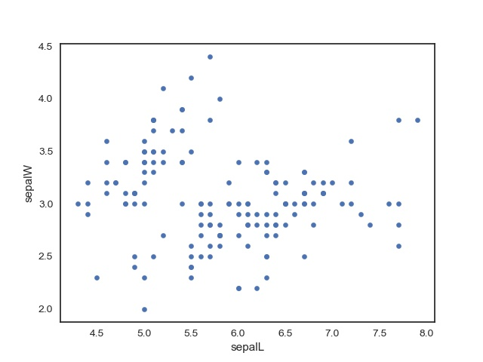

Figure 5 shows the scatter plot of all the data without labelling it by species. This shows that sepal lengths tend to be greater than sepal widths. There appears to be a cluster in the top left of the plot and a larger dispersed cluster in the mid to right section of the plot. The figure also suggests that sepal widths are negatively correlated to lengths, at least for the top cluster with the opposite pattern with the other potential cluster. Figure 6 shows the corresponding plot of the petal lengths.

*Figure 6* *Scatter plot of the Iris’s petal length versus widths in cm*

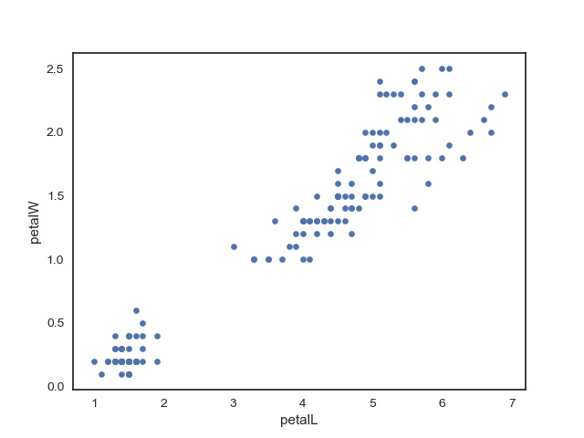

Figure 6 shows a similar pattern of lengths being greater than widths. However here, larger lengths tend to have larger widths. Two distinct clusters appear to be present, a small tight cluster in the lower left of the scatter plot and a larger more dispersed cluster in the middle to upper right of the scatter plot. The data appears to have a very strong liner relationship and a high positive correlation between petal lengths and widths.

*Figure 7 scatter plot of sepal lengths and widths in cm with correlation*

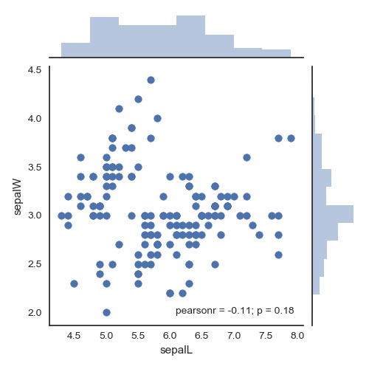

Figure 7 and 8 were produced using the seaborn module which produces a scatter plot that also calculates Pearsons correlation coefficient r. Figure 7 shows the scatter plot for sepeal lengths and widths. This shows Pearson’s r as -0.11 indicating a very slight negative corralation between sepal lengths and widths. However the association is not signifigiant as shown by the p vlaue of 0.18 > 0.05;

*Figure 8* *scatter plot of petal lengths and widths in cm with correlation*

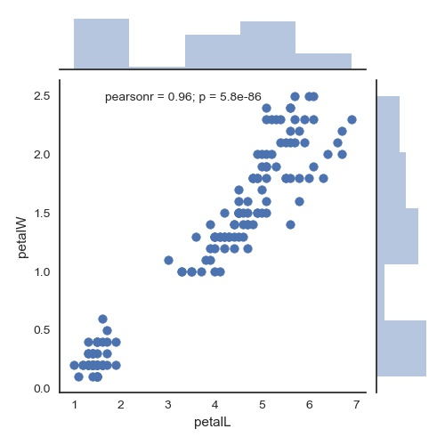

Figure 8 shows Pearson’s r at 0.96 indicating an almost perfectly positive linear relationship between petal lengths and widths. The association is significant as the p value is less than 0.05.

The seaborn module was also used to explore this difference between sepals and petals by identifying each Iris species within the scatter plot as shown in Figures 9 and 10.

*Figure 9* *scatter plot of sepal lengths and widths in cm labelled by Iris name*

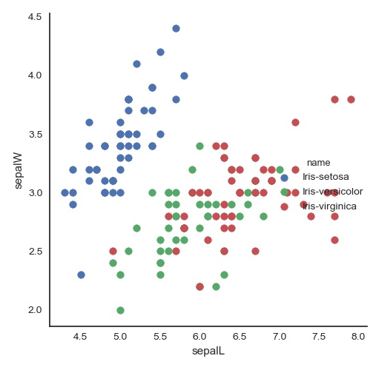

This shows a clear cluster amongst the Iris Setosa (in blue) in sepal dimensions, in the mid to upper left of the graph. The Iris Setosa appears to show a strong positive correlation in sepal length to width dimensions that is absent in the other two species.

Clusters are less pronounced between the Iris Versicolor (green) and Iris Virginica (red) although it appears that the Virginica have larger sepal dimensions than the Versicolor with some degree of overlap around the (6.25, 2.75) position. The lengths and widths also appear to be positively correlated for Virginica and Versicolor but to a far lesser degree than with the Setosa dimensions.

*Figure 10* *scatter plot of petal lengths and widths in cm labelled by Iris name*

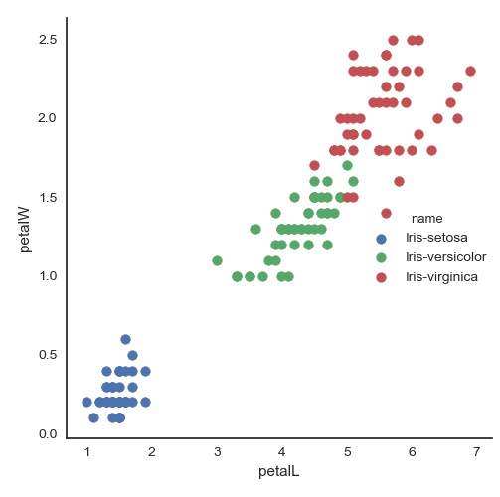

Figure 10 clearly shows three clusters with the petals. The Iris Setosa has clearly smaller petal dimensions than the other two, with the Iris Versicolor falling linearly between the Iris Setosa and Iris Virginica with some overlap between larger Versicolor petals and smaller Virginica petals. There is no overlap in petal measures between the Setosa and the other two Iris species.

##### Histograms

Figures 11– 14 show histograms of the Iris data. These graphs are saved in /project/graphs/as ISW.jpg, ISL.jpg, IPW.jpg and IPW.jpg.

*Figure 11 Histogram of Iris sepal widths Figure 12 Histogram of Iris sepal lengths*

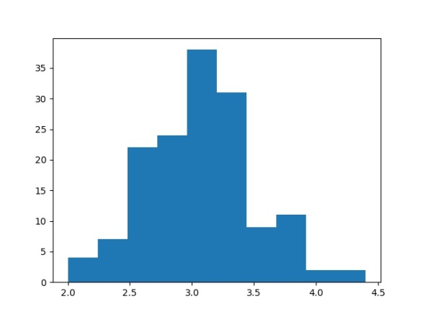 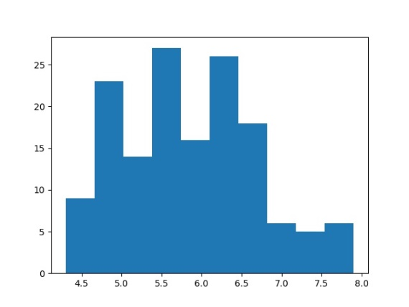

*Figure 13 Histogram of Iris petal widths Figure 14 Histogram of Iris petal lengths*

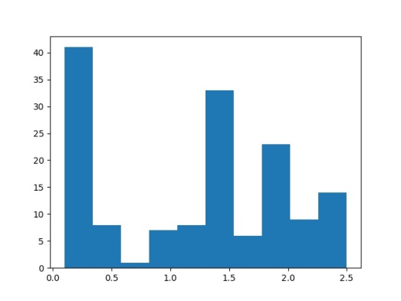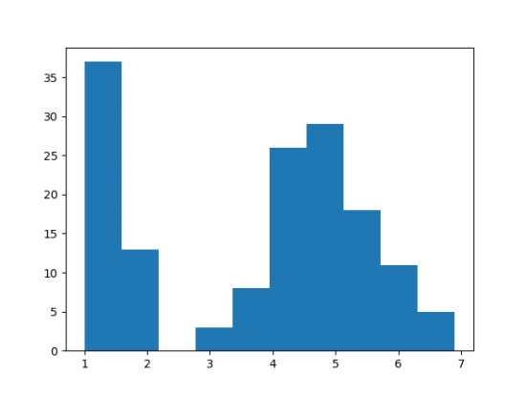

Figures 11-14 suggest that the sepal dimensions may be normally distributed, however the petal dimensions appear to be from a multimodal distribution. The data was then plotted by name.

*Figure 15 Hist Iris Setosa sepal widths Figure 16 Hist of Iris Setosa sepal lengths*

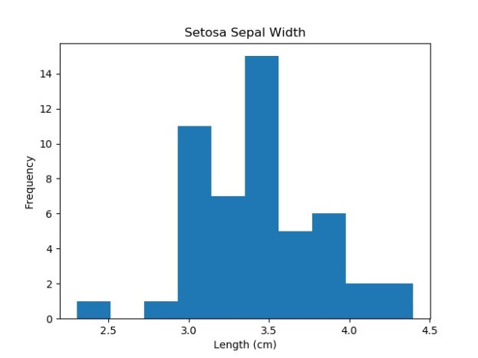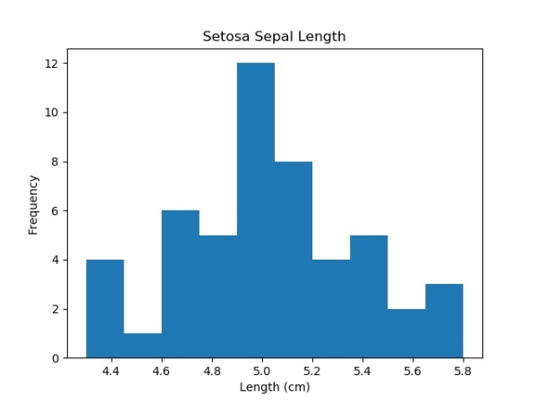

*Figure 17 Hist Iris Setosa petal widths Figure 18 Hist of Iris Setosa petal lengths*

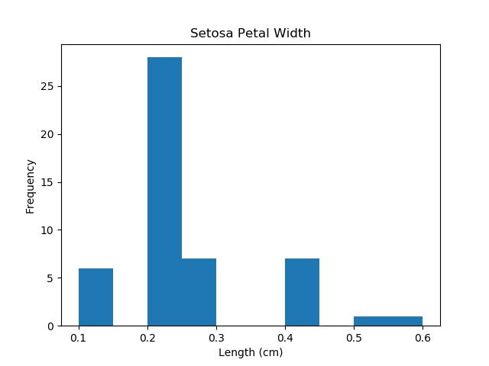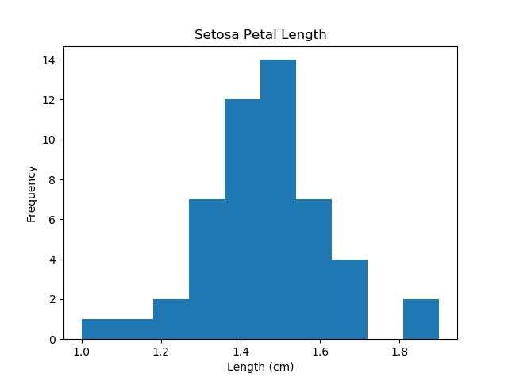

The Iris Setosa histograms do not show clear evidence of normal distribution, however the sepal and petal lengths might qualify. The petal widths do not look normally distributed and the sepal widths show signs of a bimodal distribution.

*Figure 19 Hist Iris Versicolor sepal widths Figure 20 Hist of Iris Versicolor sepal lengths*

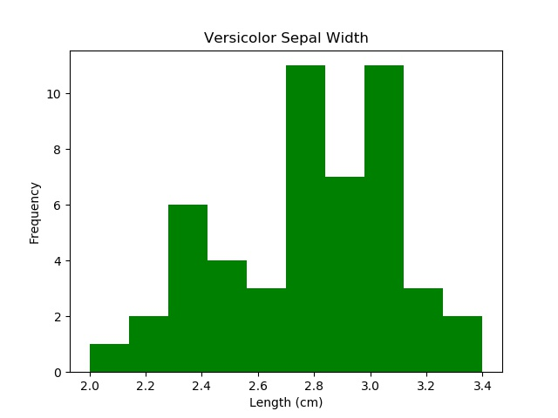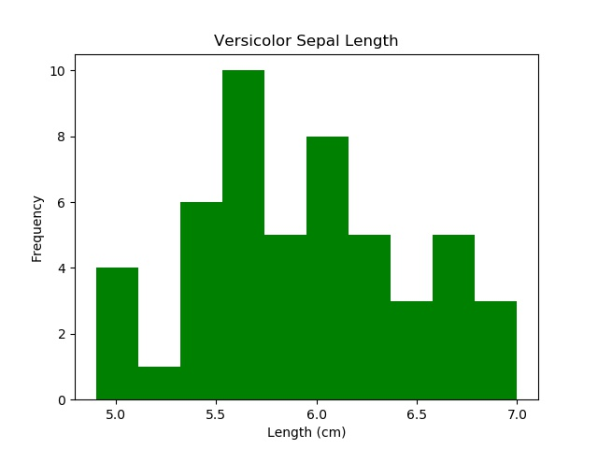

*Figure 21 Hist Iris Versicolor petal widths Figure 22Hist of Iris Versicolor petal lengths*

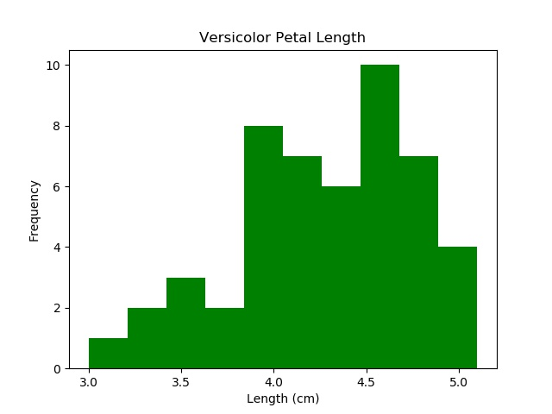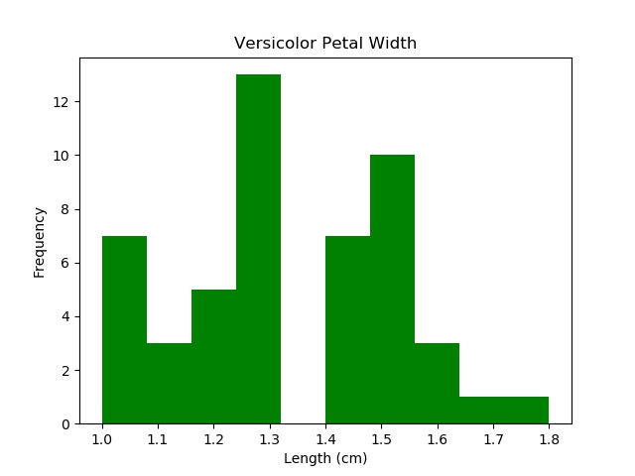

Figures 19 – 22 show the histograms of the Iris Versicolor. Again, the data is not clearly normally distributed. The sepal widths appear multimodal, while the lengths could possibly follow a normal distribution but seem skewed to the right. The petal widths suggest a multimodal distribution while the petal lengths look skewed to the left but may be normally distributed

*Figure 23 Hist Iris Virginica sepal widths Figure 24 Hist of Iris Virginica sepal lengths*

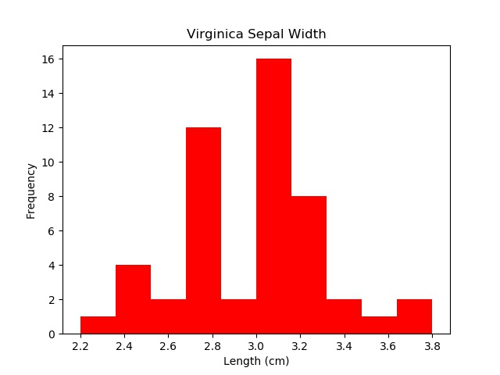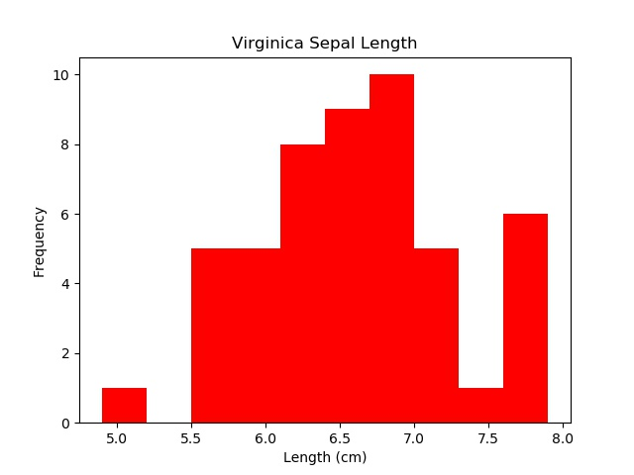

*Figure 25 Hist Iris Virginica petal widths Figure 26 Hist of Iris Virginica petal lengths*

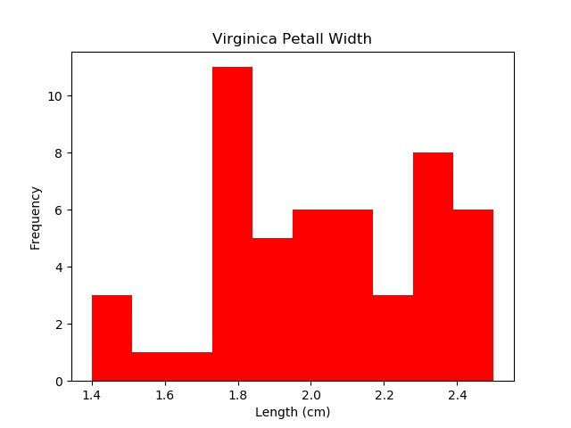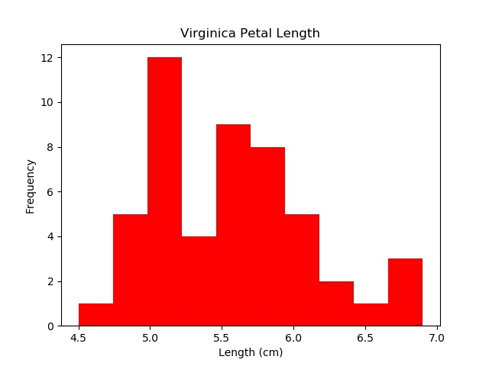

The histograms for the Iris Virginica do not show clear normal distribution, although the sepal dimensions look to have a central axis. The petal lengths appear skewed to the left and the petal widths appear multimodal.

##### Box plots

Figures 27-30 show the box plots of the sepal and petal lengths and widths sorted by Iris name.

*Figure 27* *Boxplot of sepal lengths cm*

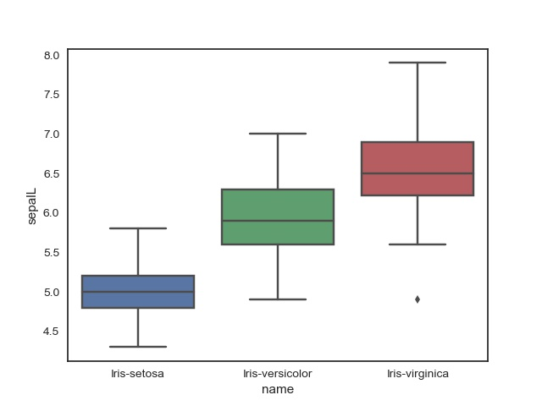

Figure 27 shows that sepal length quartiles are smallest for the Iris Setosa and largest for the Iris Virginica with the Iris Versicolor falling between them. The quartile spread is similar for the Iris Virginica and Iris Versicolor while narrower and more symmetrical for the Iris Setosa. The maximum value of the Iris Setosa and the minimum of Iris Virginica barely overlap. The maximum value of the Iris Virginica is further from its median compared to the other species of Iris.

*Figure 28* *Boxplot of sepal widths cm*

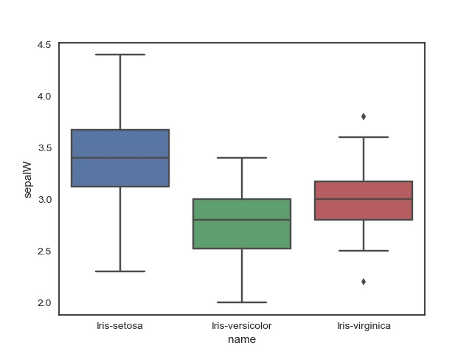

Figure 28 showed that the Iris Setosa width has the larger quartiles compared to the other two with a greater spread between its maximum and minimum. The Iris Veriscolor has the lowest quartiles while the Iris Virginica lies between the Iris setosa and Iris versicolor. The Iris Virginica also shows outliers in its highest and lowest sepal width. The range of sepal widths for the Iris Setosa encompasses all the Iris Virginica measures and the maximum and quartile span of the Iris Versicolor, with only Versicolor values close to the minimum falling outside of the Setosa’s range.

*Figure 29* *Boxplot of petal lengths cm*

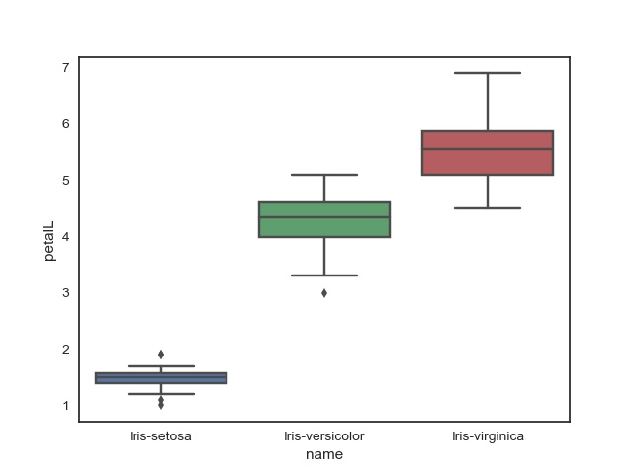

Figure 29 shows a great deal of separation between the Iris Setosa petal lengths and the other two species, with some outliers in its highest and lowest lengths. Iris Versicolour petal lengths fall between the smaller Iris Setosa and larger Iris Virginica, with no overlap with the former and some overlap between the upper Versicolor values and the mid to lower Virginica values. Some separation between the Iris Versicolor and Iris Virginica was present as the Versicolor quartiles were lower than the Virginicas’ first quartile. In addition, the Iris Versicolor petal length maximum value is below the Iris Virginica’s median petal length. There is also an outlier low value in the Iris Versicolor and low and high outliers in the Iris Setosa petal length.

*Figure 30 Boxplot of petal widths cm*

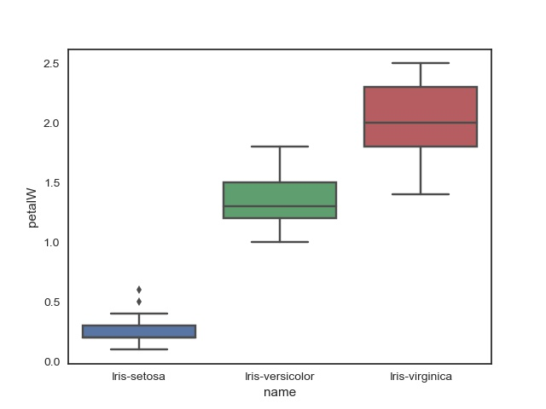

Figure 30 shows a similar pattern in petal widths as found in petal lengths. There is stronger separation between petal widths of the Iris Versicolor and Iris Virginica as the maximum value of the former is just over the first quartile of the later. There is no overlap between these two and the Iris Setosa. The Setosa also showed the presence of two outliers at the upper petal widths.

Figures 31-34 show the boxplot overlaid with the split plot to show the distribution of data over its boxplot measures.

*Figure 31Boxplot spilt plot overlay of sepal lengths in cm*

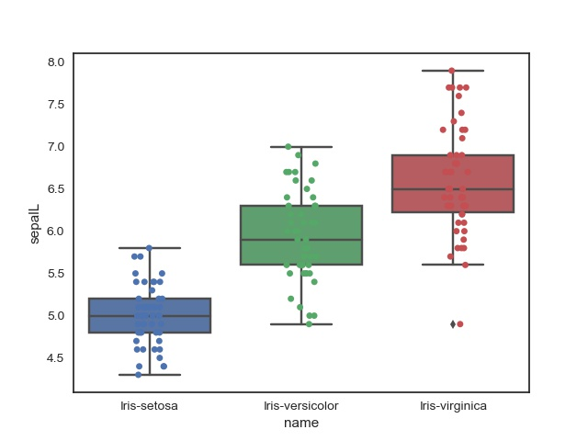

Figure 31 appears to show distribution density along within the quartiles for the Iris

Setosa sepal lengths, with less distribution within this band for the Iris versicolor. The Iris Virginica appears to show comparable distribution outside the quartiles as between them.

*Figure 32* *Boxplot spilt plot overlay of sepal widths in cm*

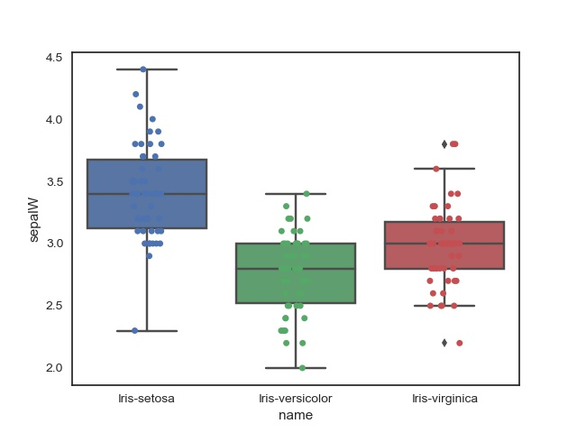

Figure 32 shows the distribution of the Iris Setosa sepal widths are clustered between the upper and lower quartile whereas the dispersion appears to be more uniform between the minimum and maximum values for the other two species. The Setosa spread shows a longer tail at the upper width values.

*Figure 33* *Boxplot spilt plot overlay of petal lengths in cm*

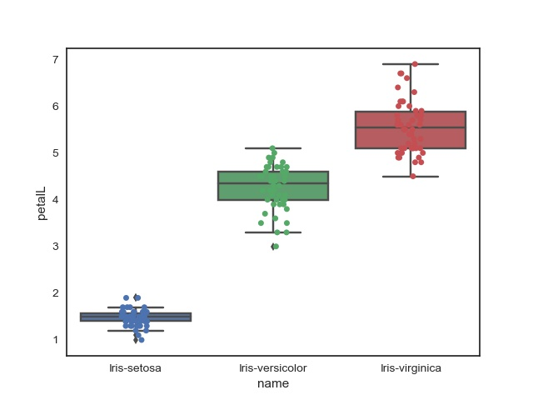

Figure 33 shows the distribution of Iris Setosa petal lengths are focused between the narrow range of its maximum and minimum length as are the other two albeit within a larger range. The Iris Versicolor petal lengths are dispersed between the lower quartile and maximum whereas the Iris Virginica shows clustering within the upper and to just under the lower quartile.

*Figure 34 Boxplot spilt plot overlay of petal widths in cm*

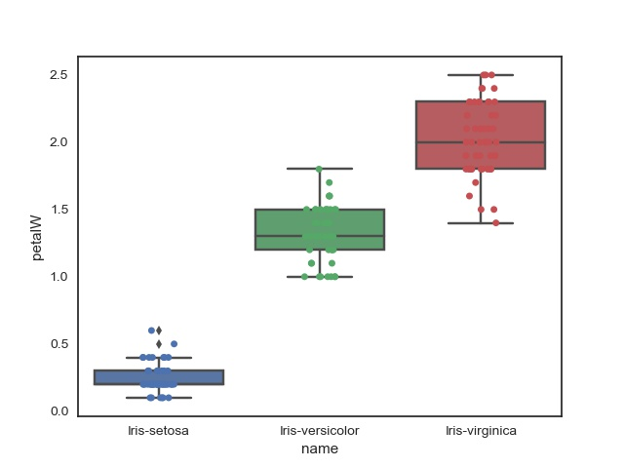

Figure 34 shows clustering of the Iris Versicolor within its upper and lower quartile but with several samples at the minimum petal width. The Iris Setosa petal widths are also focused between the narrow range of quartiles and then at the maximum and minimum. The Iris Virginia has the greatest spread and highest values of petal width.

##### Density plots

Figures 35 to 38 show the violin plots of the data which incorporates box plot details with the data’s density distribution.

*Figure 35Violin plot of sepal lengths in cm*

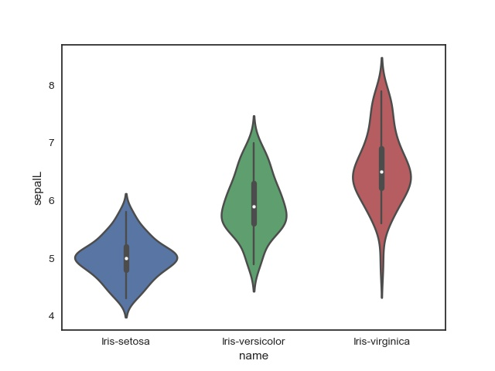

Figure 35 shows the distribution in sepal lengths for all the species is symmetrical with most values focusing round the mean (the central bulge) as in a normal distribution. The Iris Setosa shows a wide area around the mean indicating a higher probability that more samples from the Iris Setosa will have a value close to this mean. The Iris Versicolor plot indicates that further samples would fall just below the mean. However both the Iris Versicolor and Iris Virginica are narrower than the Iris Setosa, suggesting the distribution is wider than for the Setosa. The sepal lengths of the Iris Virginica show a long narrow tail for the smaller sepal lengths and slightly thicker tail for the upper sepal lengths. This suggests the density is quite dispersed. The Versicolor is not as spread out as the Virgnica and the Setosa is quite compact.

*Figure 36 Violin plot of sepal widths in cm*

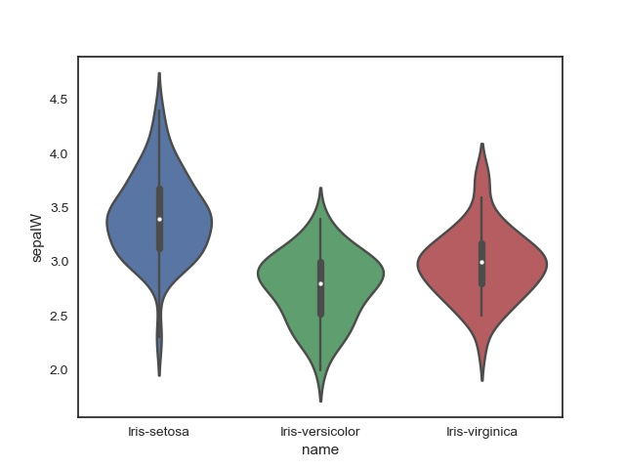

Figure 36 shows the violin plot of sepal widths. This shows a similar pattern in terms of symmetrical density around the mean, however the Setosa widths show a long tail in the lower sepal widths. The density around the mean is less pronounced in the Setosa sepal widths than it was in their lengths. Whereas the pattern is reversed with the other two as the area around their mean is more pronounced than it was with lengths. The Setosa has the highest values, then the Virginica and the Versicolor has the lowest measures in sepal widths.

*Figure 37* *Violin plot of petal lengths in cm*

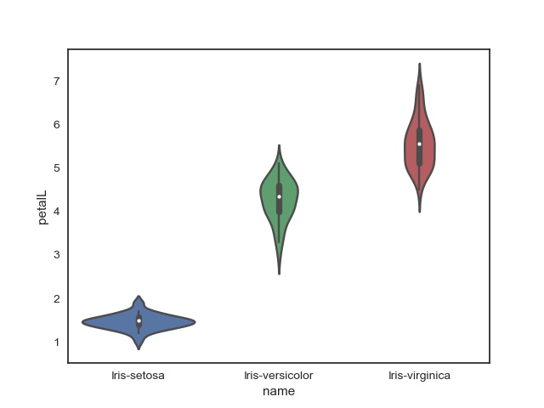

Figure 37 shows the Violin plot of petal lengths. This shows that that the data is broadly symmetrical with a bulge around the mean suggesting a normal distribution as before. The Iris Setosa central density is quite pronounced. The Iris Versicolor has a long tail at the lower petal lengths and the opposite pattern with a long tail in the upper petal lengths was found in the Iris Verginica. Both the Iris Versicolor and Iris Virginica are of broadly similar shape whereas the Iris Setosa appears to be from a different distribution.

*Figure 38 Violin plot of petal widths in cm*

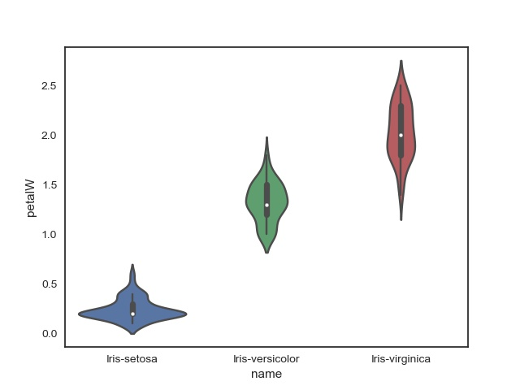

Figure 38 shows the violin plots for the petal widths. All plots look symmetrical however there appears to be a bimodal distribution in the Iris Setosa with a large density around the mean but another density developing in the upper petal widths. The Iris Versicolor shows a much milder version of this bimodality at the lower width values.

Figures 39 to 42 show the kde plots of the Iris data.

*Figure 39* *kde plot of Iris sepal lengths*

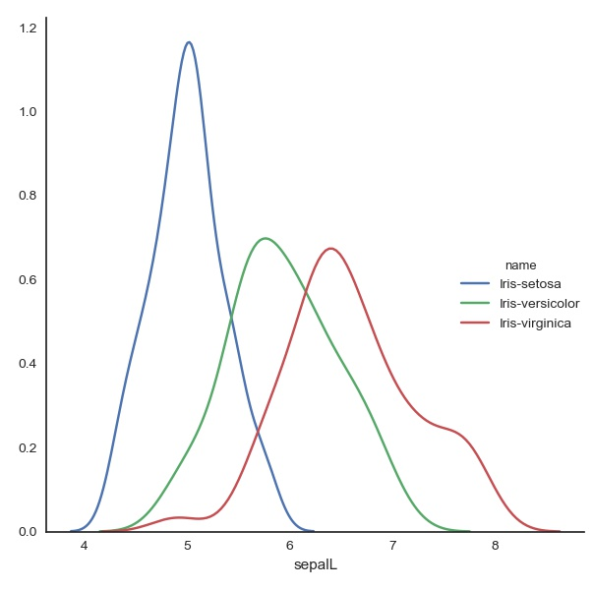

This shows that each of the species appears to have normally distributed sepal lengths with the distributions of the Iris Setosa differing from the more similar Versicolor and Virginica. The Setosa’s mean peak is higher than the similar apexes of the other two. The Iris Virginica appears to have a bump in the upper sepal length values and a dip in the lower sepal length values.

*Figure 40* kde plot of Iris sepal widths

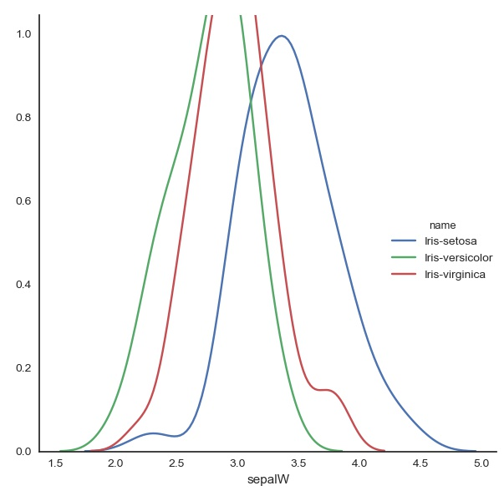

This shows a similar pattern to the sepal lengths with data looking normally distributed however the plot of the Setosa’s sepal widths is now the smallest. The graphs all look to be of comparable thickness. However the graph is cut at the top so difficult to interpret. The Virginica shows a bump at the upper values while the Setosa shows a dip at the lower values.

*Figure 41* kde plot of Iris petal lengths

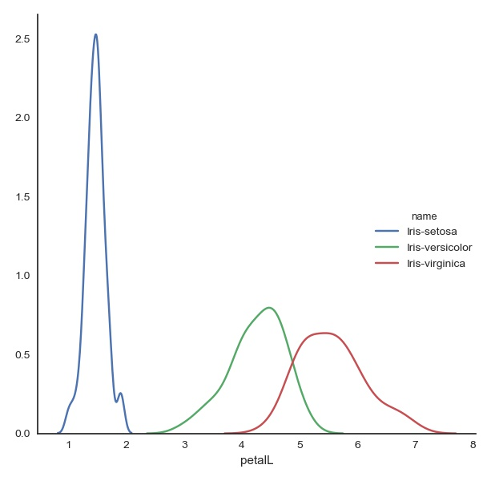

This shows that the kernel density estimation is similar for the Versicolor and Virginica with overlapping populations. Whereas the Setosa has a different shape and a small peak at its upper values. The Versicolor and Virginica look normally distributed however there appears to be some skewness in the right for the Virginica and left for the Versicolor. There is a mini peak at the upper values of the Setosa.

*Figure 42* kde plot of Iris petal widths

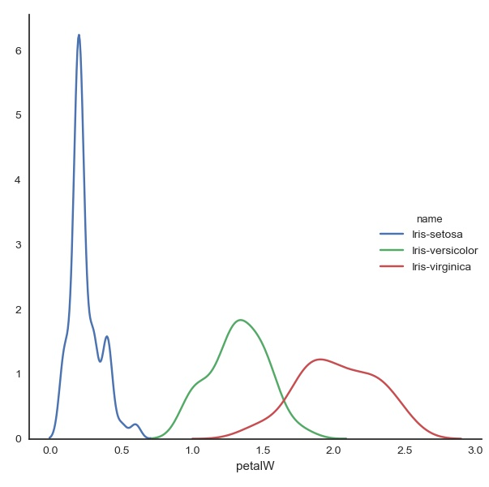

This shows the kde plot of Iris petal widths. The data does not appear to be normally disturbed. There appears to be 3 peaks in the Setosa plot and skewness and a mini hump on the other two species. The Versicolor has a hump on the left and is left skewed and the Virginica is right skewed with a hump on the right.

Figure 43 and 44 show the pair plots of the bivariate relationship between each pair of features. Figure 43 shows histograms along the diagonal and figure 44 shows kde plots along the diagonal.

*Figure 43* pairplot of bivariate relations of the Iris data with histogram along the diagonal

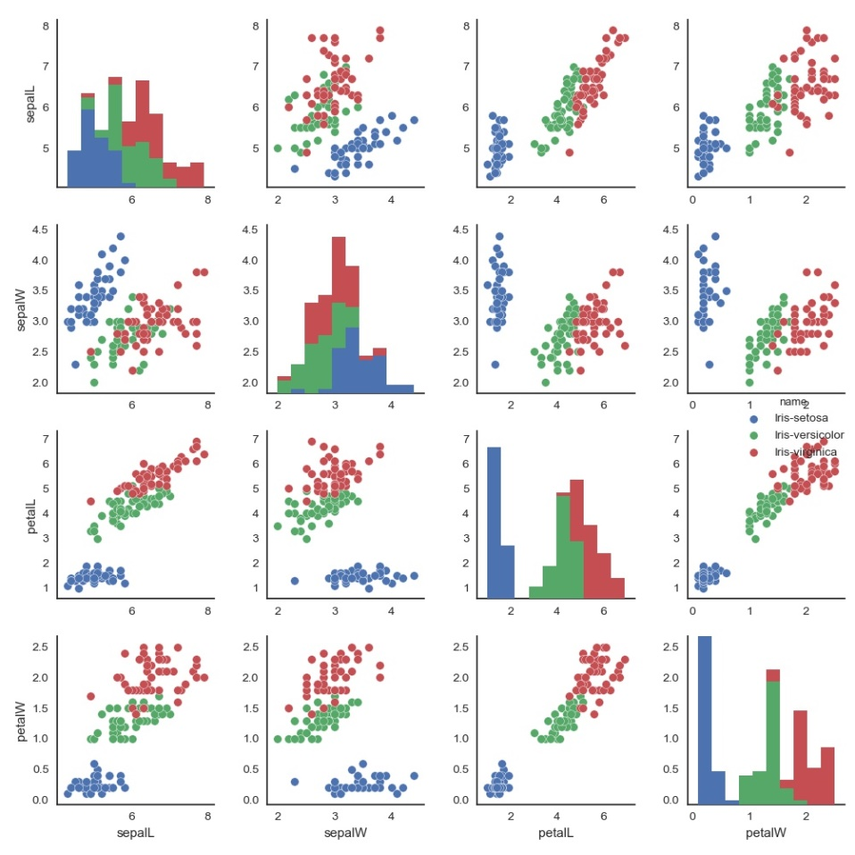

Figure 43 with histograms along the diagonal, shows each measure plotted against the other measures. In each case the Setosa cluster remains clear with the Versicolor and Virginica cluster emerging strongest with petal lengths (3rd column and 3rd row). The Versicolor and Virginica cluster appears weakest when comparing sepal widths.

*Figure 44* pairplot of bivariate relations of the Iris data with kde plot along the diagonal

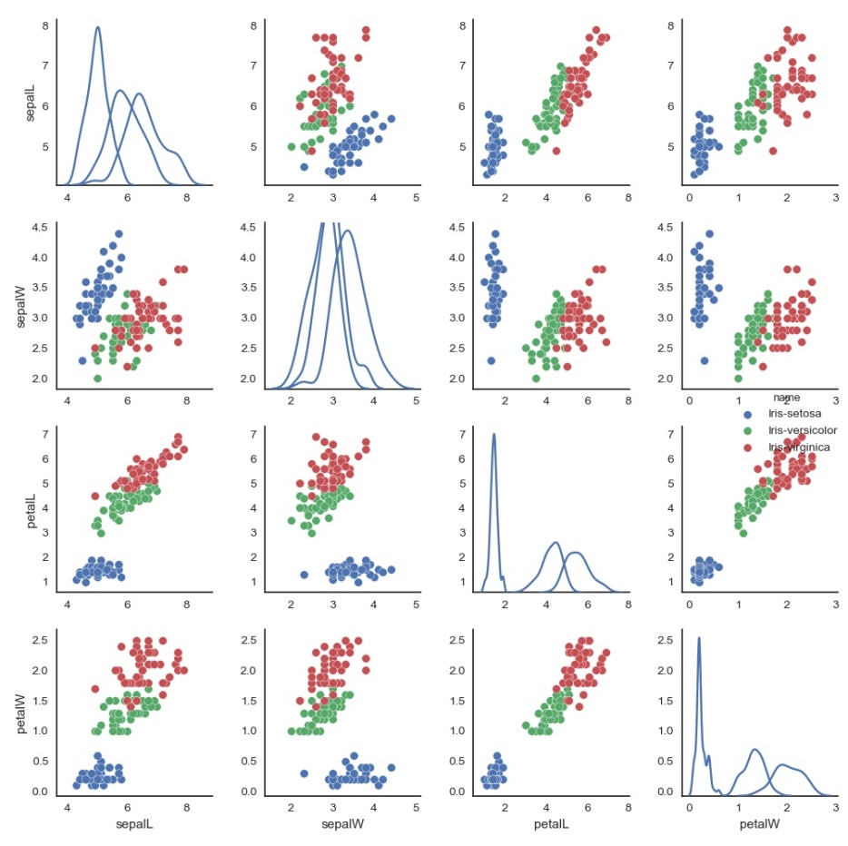

Figure 44 shows the same scatter plots as in figure 26 however here, the kernel density estimations are plotted along the diagonal for comparison.

##### High dimensional plots

*Figure 45 Andrew Curves plot of Iris data*

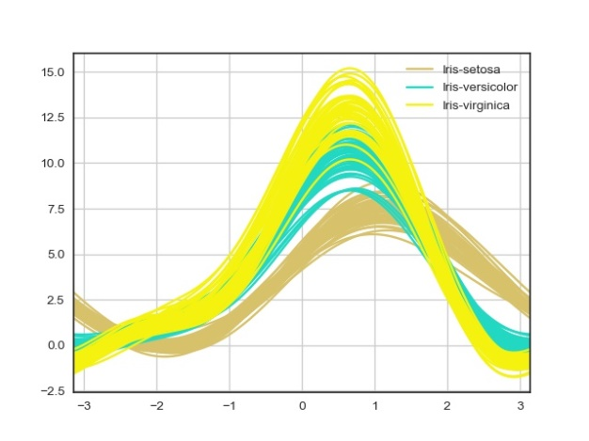

Figure 45 plots the Andrew Curves for the Iris data. This shows that the Iris Setosa (in tan) has tightly bound curves and cross the other two species at two narrow ranges at the lower and upper sections. In contrast there is a great deal of overlap with the Iris Versicolor and Iris Virginica, particularly in the lower ranges, with hardly any in the upper range. The Iris Versicolor has smaller peaked Andrew curves in mid ranges but is larger than the Iris Setosa curves.

*Figure 46* *Parallel Coordinates plot of Iris data*

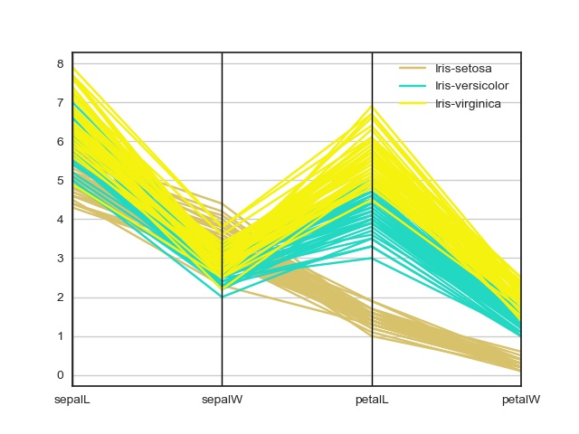

Figure 46 plots the parallel coordinates of the Iris data. This shows sepal lengths are high (between 4 and 8) for all species of Irises sampled. Sepal widths are lower for the Versicolor and Virginica and higher in the case of the Setosa. The difference between sepal lengths and widths is more extreme for the Versicolor and Virginica as seen by the low vertices at sepal widths and the less severe of the Setosa. The Setosa petal lengths and petal widths continue their downward trajectory whereas the Versicolor and Virginia move in the upward direction. The petal widths for the Setosa is its lowest values while the petal widths of the other two show some overlap with each other [1, ~2.8] and are only slightly lower than their sepal widths [2 ~4]. The Setosa petal lengths and widths show no overlap with the other petal lengths and widths whereas some overlap is present with its sepal dimensions. The data shows that the lows at sepal widths are tighter than the more disperse peak at the petal lengths and widths in the case of Versicolor and Virginia.

*Figure 47* *Radviz plot of Iris data*

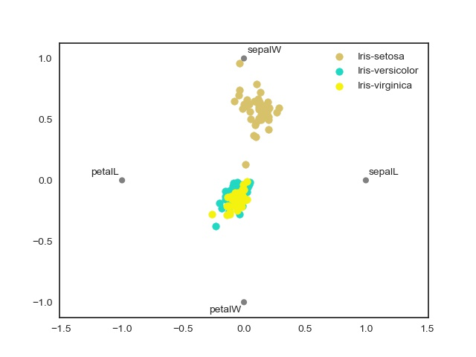

Figure 47 shows the Radviz plot of the Iris data. This shows that the Virginia and Versicolor samples are close to the centre of the plot. This indicates that the measures for these species are approximately equal across their dimensions or have opposing pulls with one dimension going in the opposite direction to the other dimension. The Setosa data points (bar one near the centre) are pulled towards the sepal widths. This indicates that sepal widths are much greater than its other measures.

#### *Inferential* *statistics*

The data as seen by the histograms, figures 15 to 26, did not show clear evidence for normal distribution. However this could be due to the low sample size. It would be useful to test the measures for normal distribution and apply the t-test if applicable. A one way sample t – test was conducted. In all cases the null hypothesis was

H0: u1=u2 i.e. the means of the Iris species (Setosa, Versicolor or Virginica) measure (sepal or petal, length or width) were the same. The alternative hypothesis was

HA: u1 ≠ u2 that is, that the means of the Iris species measure in question were not the same.

The location for this sections code is /project/pyscripts/infer.py. This code also checked the assumptions for t-test before applying it. The results are noted below.

##### Comparing sepal widths

A one way t-test between the Iris Setosa and Iris Versicolor sepal widths was conducted. This tested if there is a significant difference in sepal widths between the Iris Setosa and Iris Versicolor. The Iris Setosa’s average sepal width (M=3.418, SD= 0.377) was wider and has greater variation than Iris versicolor (M= 2.77, SD=0.311). Levene’s test for homogeneity of variances indicated equality of variance (F=1.057*, p=0.306*); therefore an Independent t-test was used. Results showed a significant difference in sepal widths between Iris Setosa and Iris Versicolor (t(98)=9.283, *p=<0.05*).

A one way t-test between the Iris Setosa and Iris Virginica sepal widths was conducted. This tested if there is a significant difference in sepal widths between the Iris Setosa and Iris Virginica. The Iris Setosa’s average sepal width (M=3.418 , SD=0.377 ) was wider and has slightly greater variation than Iris Virginica (M= 2.974, SD=0.319). Levene’s test for homogeneity of variances indicated equality of variance (F= 0.967, *p=0.181*); therefore an Independent t-test was used. Results showed a significant difference in sepal widths between Iris Setosa and Iris Virginica (t(98)=6.289*, p<0.05*).

A one way t-test between the Iris Versicolor and Iris Virginica sepal widths was conducted. This tested if there is a significant difference in sepal widths between the Iris Versicolor and Iris Virginica. The Iris Versicolor’s average sepal width (M=2.77, SD=0.311) is shorter with slightly less variation than Iris Virginica (M=2.974 , SD=0.319). Levene’s test for homogeneity of variances indicated equality of variance (F=0.087, *p=0.768*); therefore an Independent t-test was used. Results showed a significant difference in sepal widths between Iris Versicolor and Iris Virginica (t(98) = 3.206*, p<0.05*).

##### Comparing sepal lengths

This test investigated there was a significant difference in sepal lengths between the Iris Setosa and Iris Versicolor. The Iris Setosa’s average sepal length (M=5.006, SD=0.349) is slightly smaller and has less variation than Iris Versicolor (M=5.936, SD=0.511). Levene’s test for homogeneity of variances was significant (F=8.172*, p<0.05*); therefore Welch's t-test was used. Results showed a significant difference in sepal widths between Iris Setosa and Iris Versicolor (t(86.538) = -10.521, *p<0.05*).

This test investigated if there was a significant difference in sepal lengths between the Iris Setosa and Iris Virginica. The Iris Setosa’s average sepal length (M= 5.006, SD=0.349) is smaller and has less variation than Iris Virginica (M=6.588, SD=0.629). Levene’s test for homogeneity of variances was significant (F=11.454, p=0.001); therefore Welsh's t-test was used. Results showed a significant difference in sepal lengths between Iris Setosa and Iris-Virginica (t(76.516)=-15.386, *p<0.05*).

This test investigated if there is a significant difference in sepal lengths between the Iris Versicolor and Iris Virginica. The Iris Versicolor's average sepal length (M=5.936, SD = 0.511) is shorter and has slightly less variation than Iris Virginica (M=6.588 , SD=0.629). Levene’s test for homogeneity of variances indicated equality of variance (F=1.025, p=0.314); therefore an Independent t-test was used. Results showed a significant difference in sepal widths between Iris Versicolor and Iris Virginica (t(98)=-5.629, *p<0.05*).

##### Comparing petal widths

This tested if there was a significant difference in petal widths between the Iris Setosa and Iris Versicolor. The Iris Setosa’s average petal width (M= 0.244, SD=0.106) was wider and has less variation than Iris Versicolor (M=0.106 , SD=1.326 ). Levene’s test for homogeneity of variances was significant and both the Sestosa and versicolor failed the Shapiro Wilk test for normal distribution. Thus the t test was not conducted as stands.

This tested if there is a significant difference in petal widths between the Iris Setosa and Iris Virginica. The Iris Setosa’s average petal width (M=0.244, SD=0.106 ) is smaller and has less variation than Iris Virginica (M=2.026, SD=0.272). Levene’s test for homogeneity of variances was significant (F=38.107, p=1.517e-8); The Shapiro Wilk for the Iris setosa petal widths was significant (F=0.814, p=1.853e-06) whereas the Shapiro Wilk test for the Iris Virginica was not significant (F=0.960, p=0.09) therefore no t-test was performed as stands.

This tested if there is a significant difference in petal widths between the Iris versicolor and Iris Virginica. The Iris Versicolor's average petal width (M=1.326 , SD=0.196) is smaller and has less variation than Iris Virginica (M=2.026 , SD=0.272). Levene’s test for homogeneity of variances was significant (F=6.546, p=0.012) so variances were unequal; The Iris Versicolor failed the Shapiro Wilks test for normal distribution hence no t-test was performed.

##### Comparing petal lengths

This tested if there is a significant difference in petal lengths between the Iris Setosa and Iris Versicolor. The Iris Setosa’s average petal length (M=1.464, SD=0.172 ) was smaller and has less variation than Iris-versicolor (M=4.26, SD=0.465). Levene’s test for homogeneity of variances was not significant (F=30.897, p=2.348); therefore an Independent t-test was used. Results showed a significant difference in petal lengths between Iris Setosa and Iris Versicolor (t(62.118)=-39.469, *p<0.05*).

This tested if there is a significant difference in petal lengths between the Iris Setosa and Iris Virginica. The Iris Setosa’s average petal length (M=1.464 , SD= 0.172) was much smaller and has less variation than Iris Virginica (M=5.552, SD=0.546). Levene’s test for homogeneity of variances was significant (F=39.977, p=7.651e-09); therefore an Welch's t-test was used. Results showed a significant difference in petal lengths between Iris Setosa and Iris Virginica (t(58.593)=-49.9657, *p<0.05*).

This tested if there is a significant difference in petal lengths between the Iris Versicolor and Iris Virginica. The Iris Versicolor's average petal length (M=4.26, SD=0.465) is smaller and has less variation than Iris Virginica (M=5.552 , SD=0.546). Levene’s test for homogeneity of variances indicated equality of variance (F=1.067, p=0.304); therefore an Independent t-test was used. Results showed a significant difference in petal lengths between Iris Versicolor and Iris Virginica (t(98)=29.023 *p<0.05*).

The above findings are summarised in table 7 below.

|  |  |  |  |  |  |  |  |  |  |  |  |  |  |  |
| --- | --- | --- | --- | --- | --- | --- | --- | --- | --- | --- | --- | --- | --- | --- |
| *Table 7*: Summary of hypotheses testing | | | | | | | | | | | | | | |
| Iris |  |  | **Sepals** | | | | | | **Petals** | | | | | |
|  |  |  | **Setosa** | | **Versicolor** | | **Virginica** | | **Setosa** | | **Versicolor** | | **Virginia** | |
|  |  |  | **Width** | **Length** | **Width** | **Length** | **Width** | **Length** | **Width** | **Length** | **Width** | **Length** | **Width** | **Length** |
| Sepal | **Setosa** | **Width** |  |  | Sig t |  | Sig t |  |  |  |  |  |  |  |
| **Length** |  |  |  | Sig w-t |  | Sig w-t |  |  |  |  |  |  |
| **Versicolor** | **Width** | Sig t |  |  |  | Sig t |  |  |  |  |  |  |  |
| **Length** |  | Sig w-t |  |  |  | Sig t |  |  |  |  |  |  |
| **Virginica** | **Width** | Sig t |  | Sig t |  |  |  |  |  |  |  |  |  |
| **Length** |  | Sig w-t |  | Sig t |  |  |  |  |  |  |  |  |
| Petals | **Setosa** | **Width** |  |  |  |  |  |  |  |  | NA |  | NA |  |
| **Length** |  |  |  |  |  |  |  |  |  | Sig t |  | Sig w-t |
| **Versicolor** | **Width** |  |  |  |  |  |  | NA |  |  |  | NA |  |
| **Length** |  |  |  |  |  |  |  | Sig t |  |  |  | Sig t |
| **Virginica** | **Width** |  |  |  |  |  |  | NA |  | NA |  |  |  |
| **Length** |  |  |  |  |  |  |  | Sig w-t |  | Sig t |  |  |

|  |  |  |  |  |  |  |  |  |  |
| --- | --- | --- | --- | --- | --- | --- | --- | --- | --- |
|  |  | Setosa | | Versicolor | | Setosa | | Versicolor | |
|  |  | **Width** | **Length** | **Width** | **Length** | **Width** | **Length** | **Width** | **Length** |
| Versicolor | **Width** | Sig t |  |  |  | NA |  |  |  |
| **Length** |  | Sig w-t |  |  |  | Sig t |  |  |
| Virginica | **Width** | Sig t |  | Sig t |  | NA |  | NA |  |
| **Length** |  | Sig w-t |  | Sig t |  | Sig w-t |  | Sig t |

Intable 7, Sig t represents independent t test significance, Sig w-t represents dependent t test significance and NA represents not tested due to failure of test assumptions. The table shows that where the tests were significant in an independent t test for Setosa sepals with the other species they were not applicable with the Setosa petals and the other species. The variances were not equal in the Setosa sepal lengths tested against the other two species sepal lengths yet still significant. The versicolor and Virginica sepal lengths and widths were significant in an independent t-test. Equal variance was also not assumed in Setosa and Virginica t-test of petal measures but still significant.

### Discussion

This project explored the Iris data set in a number of approaches. Initially descriptive analysis of the Iris data set was taken. Here, the sepal length measures had the greatest mean, minimum, maximum and inter quartile range with the petal widths having the smallest (table 2). Grouping the data showed that the sepal length data was largely influenced by the Iris Setosa sepal length. this was mostly due to the large sepal lengths of the Iris Setosa. The opposite pattern was seen for the Setosa’s petal width which bore little relation to the full iris dataset petal widths.

Scatter plots of the unlabelled data plotted against their respective lengths and widths showed a clear positively correlated linear relationship with petals and two strong clusters, with one cluster being more compact than the other figure 8. The pattern in the sepal scatter plot was not as pronounced though two weak clusters could also be identified figure 7.

Identifying the type of Iris confirmed two clusters as the Iris Setosa was the clear cluster in the petals and the week cluster in the sepals. It was also possible to split the 2nd cluster into two as the scatter plot for the petals showed Iris Virginica samples mostly rested along the top right of the plot with the Iris Versicolor upper values overlapping lower Iris Virginica values figure 10. This pattern was also present with the sepals, however the overlapping between the Virginica and Versicolor was more pronounced and covered a greater range.

Histogram plots did not show a clear normal distribution but there was signs of symmetrical density around the mean in the Setosa petal and sepal lengths figures 18 and 16. The remaining histograms suggested bi or multimodal distribution.

Box plots of the sepal lengths compared to sepal widths showed different patterns with the Setosa having the lowest box plot followed by the Versicolor with Virginica having the largest. However the largest was the Setosa followed by the Virginica and Versicolor being the lowest with sepal widths. The petal lengths and widths followed the same pattern as the sepal lengths with the Setosa at the lower end of the scale, Versicolor in the mid range and Versicolor at the upper end. The box plots also showed several outliers. Iris Virginia has a very low sepal length, upper and lower outliers in sepal widths. The Iris Versicolor had one low outlier in petal lengths and the Iris Setosa had several upper and lower outliers in its petal lengths and 2 upper outliers in its petal widths.

The violin plots (figure 35-38) showed that the Versicolor and Virginica data resembled each other more than they resembled the Setosa. The Setosa showed the most similarly with the other two species in its sepal widths. All plots were broadly symmetrical and were denser close to or at their mean. The Setosa violin plot was most different from the other two for petals, particularly for petal widths figure 38.

The Kernel density estimation plots (figures 39-42) showed elements of a normal distribution however there were signs skewness in opposite directions with the Versicolor and Virginica data and also signs of bi or multimodal distribution. This was most pronounced with the kde plot of petal widths.

High dimensional plots showed distribution similarity around central values between species as seen in the Andrew Curves figure 45. Parallel coordinate plot also showed Versicolor and Virginica follow the same trajectory along its petal and sepal measures whereas the Setosa differs along petal lengths figure 46. The Setosa is also marked out in the Radviz plot as its values are heavily influenced by its sepal width.

Inferential analysis (one way t-test) showed the Iris Setosa sepal widths were more than likely from a different normal distribution than the Versicolor and Virginica. In addition the Setosa sepal lengths also appeared to be from a different distribution from the other two but with less degrees of freedom. The Versicolor and Virginia sepals also appeared to be from different populations. However the histograms showed evidence of skewness with Versicolor and Virginica sepals. It would be useful to retest using a larger sample size. While the sepals, particularly the Setosa, showed signs of normal distribution and significant differences in means, the petals were a different story.

However the Setosa and Versicolor petal widths did not pass tests for normal distribution. The Setosa and Versicolor petal lengths did pass tests for normal distribution for an independent t test with significant mean differences in petal lengths between Setosa tested with Versicolor, and Versicolor tested with Virginica. Setosa and Virginica petal lengths were also significant with Welch’s t-test. However skewness was present in the histograms of petal lengths of the Versicolor and Virginica so less confidence should be put in this statistic compared to the more normal looking Setosa petal lengths. Again, it would be useful to retest with a larger sample size..

In conclusion, this analysis showed several areas of interest and lines for further inquiries. Two clear clusters, with a third emerging once data are categorised were present. The Iris Setosa petals appear to not be normally distributed and heavily influenced by sepal widths, Figure 47. It may be that the sepal width is influencing the distribution of petal, possibly pulling the distribution in the direction of bimodality. Sepal widths also show a different pattern than the rest of the data as seen with box plots. However, the violin plots of the Setosa sepal widths resembled the shape of the Virginia and Versicolor sepal widths, if not its direction, more so than its other measures did. Some points to consider in this analysis include the number of samples. 50 samples from each species may not be sufficient to test for normal distribution. The presence of outliers may also indicate poor sample representation or signify an area requiring further analysis. The data used in this project contains 3 errors in 2 data points both of which come from the Iris Setosa and include 2 errors with sepal width (Iris Data, 1988). It would be useful to re analyse this data with adjustments for outliers and errors. Fisher investigated if the Versicolor was a hybrid of the Setosa and Virginica. If this conjecture has merit it may explain the opposing skewness shown by the Versicolor and Virginica. The Versicolor may be an early species branched off from the Virginia. This would explain Versicolors’ similarity to Virginica but also reflect the strong influence by the genes from the Setosa pulling sepal widths in the opposite direction from Virginica.

**References**

Fisher, R. A. (1936) The use of multiple measurements in taxonomic problems. Ann. Eugenics 7, pt. II, 197-188

“Iris Data Set”, (donated 1988). Retrieved from <http://archive.ics.uci.edu/ml/datasets/Iris> on 1/4/2018

“Iris Data” (donated 1988) Retrieved from [http://archive.ics.uci.edu/ml/machine-learning-databases/Iris/Iris.data on 22/3/2018](http://archive.ics.uci.edu/ml/machine-learning-databases/iris/iris.data%20on%2022/3/2018)

J. C. Bezdek, J. M. Keller, R. Krishnapuram, L. I. Kuncheva and N. R. Pal, (1999) "Will the real Iris data please stand up?," in IEEE Transactions on Fuzzy Systems, vol. 7, no. 3, pp. 368-369. doi: 10.1109/91.771092

[wiki](https://en.wikipedia.org/wiki/Iris_flower_data_set) [stack exchange](https://stats.stackexchange.com/questions/30788/whats-a-good-way-to-use-r-to-make-a-scatterplot-that-separates-the-data-by-trea/30789#30789) [link](https://stats.stackexchange.com/questions/74776/what-aspects-of-the-Iris-data-set-make-it-so-successful-as-an-example-teaching) [link](https://archive.ics.uci.edu/ml/datasets/Iris) [](https://www.kaggle.com/sridharcr/data-analysis-Iris-dataset) [](https://www.kaggle.com/benhamner/python-data-visualizations) [](http://scikit-learn.org/stable/tutorial/basic/tutorial.html) []() #

**Appendix**

Table 1 The Iris Data Set (measures in cm)

|  |  |  |  |  |  |
| --- | --- | --- | --- | --- | --- |
|  | sepalL | sepalW | petalL | petalW | name |
| 0 | 5.1 | 3.5 | 1.4 | 0.2 | Iris-setosa |
| 1 | 4.9 | 3 | 1.4 | 0.2 | Iris-setosa |
| 2 | 4.7 | 3.2 | 1.3 | 0.2 | Iris-setosa |
| 3 | 4.6 | 3.1 | 1.5 | 0.2 | Iris-setosa |
| 4 | 5 | 3.6 | 1.4 | 0.2 | Iris-setosa |
| 5 | 5.4 | 3.9 | 1.7 | 0.4 | Iris-setosa |
| 6 | 4.6 | 3.4 | 1.4 | 0.3 | Iris-setosa |
| 7 | 5 | 3.4 | 1.5 | 0.2 | Iris-setosa |
| 8 | 4.4 | 2.9 | 1.4 | 0.2 | Iris-setosa |
| 9 | 4.9 | 3.1 | 1.5 | 0.1 | Iris-setosa |
| 10 | 5.4 | 3.7 | 1.5 | 0.2 | Iris-setosa |
| 11 | 4.8 | 3.4 | 1.6 | 0.2 | Iris-setosa |
| 12 | 4.8 | 3 | 1.4 | 0.1 | Iris-setosa |
| 13 | 4.3 | 3 | 1.1 | 0.1 | Iris-setosa |
| 14 | 5.8 | 4 | 1.2 | 0.2 | Iris-setosa |
| 15 | 5.7 | 4.4 | 1.5 | 0.4 | Iris-setosa |
| 16 | 5.4 | 3.9 | 1.3 | 0.4 | Iris-setosa |
| 17 | 5.1 | 3.5 | 1.4 | 0.3 | Iris-setosa |
| 18 | 5.7 | 3.8 | 1.7 | 0.3 | Iris-setosa |
| 19 | 5.1 | 3.8 | 1.5 | 0.3 | Iris-setosa |
| 20 | 5.4 | 3.4 | 1.7 | 0.2 | Iris-setosa |
| 21 | 5.1 | 3.7 | 1.5 | 0.4 | Iris-setosa |
| 22 | 4.6 | 3.6 | 1 | 0.2 | Iris-setosa |
| 23 | 5.1 | 3.3 | 1.7 | 0.5 | Iris-setosa |
| 24 | 4.8 | 3.4 | 1.9 | 0.2 | Iris-setosa |
| 25 | 5 | 3 | 1.6 | 0.2 | Iris-setosa |
| 26 | 5 | 3.4 | 1.6 | 0.4 | Iris-setosa |
| 27 | 5.2 | 3.5 | 1.5 | 0.2 | Iris-setosa |
| 28 | 5.2 | 3.4 | 1.4 | 0.2 | Iris-setosa |
| 29 | 4.7 | 3.2 | 1.6 | 0.2 | Iris-setosa |
| 30 | 4.8 | 3.1 | 1.6 | 0.2 | Iris-setosa |
| 31 | 5.4 | 3.4 | 1.5 | 0.4 | Iris-setosa |
| 32 | 5.2 | 4.1 | 1.5 | 0.1 | Iris-setosa |
| 33 | 5.5 | 4.2 | 1.4 | 0.2 | Iris-setosa |
| 34 | 4.9 | 3.1 | 1.5 | 0.1 | Iris-setosa |
| 35 | 5 | 3.2 | 1.2 | 0.2 | Iris-setosa |
| 36 | 5.5 | 3.5 | 1.3 | 0.2 | Iris-setosa |
| 37 | 4.9 | 3.1 | 1.5 | 0.1 | Iris-setosa |
| 38 | 4.4 | 3 | 1.3 | 0.2 | Iris-setosa |
| 39 | 5.1 | 3.4 | 1.5 | 0.2 | Iris-setosa |
| 40 | 5 | 3.5 | 1.3 | 0.3 | Iris-setosa |
| 41 | 4.5 | 2.3 | 1.3 | 0.3 | Iris-setosa |
| 42 | 4.4 | 3.2 | 1.3 | 0.2 | Iris-setosa |
| 43 | 5 | 3.5 | 1.6 | 0.6 | Iris-setosa |
| 44 | 5.1 | 3.8 | 1.9 | 0.4 | Iris-setosa |
| 45 | 4.8 | 3 | 1.4 | 0.3 | Iris-setosa |
| 46 | 5.1 | 3.8 | 1.6 | 0.2 | Iris-setosa |
| 47 | 4.6 | 3.2 | 1.4 | 0.2 | Iris-setosa |
| 48 | 5.3 | 3.7 | 1.5 | 0.2 | Iris-setosa |
| 49 | 5 | 3.3 | 1.4 | 0.2 | Iris-setosa |
| 50 | 7 | 3.2 | 4.7 | 1.4 | Iris-versicolor |
| 51 | 6.4 | 3.2 | 4.5 | 1.5 | Iris-versicolor |
| 52 | 6.9 | 3.1 | 4.9 | 1.5 | Iris-versicolor |
| 53 | 5.5 | 2.3 | 4 | 1.3 | Iris-versicolor |
| 54 | 6.5 | 2.8 | 4.6 | 1.5 | Iris-versicolor |
| 55 | 5.7 | 2.8 | 4.5 | 1.3 | Iris-versicolor |
| 56 | 6.3 | 3.3 | 4.7 | 1.6 | Iris-versicolor |
| 57 | 4.9 | 2.4 | 3.3 | 1 | Iris-versicolor |
| 58 | 6.6 | 2.9 | 4.6 | 1.3 | Iris-versicolor |
| 59 | 5.2 | 2.7 | 3.9 | 1.4 | Iris-versicolor |
| 60 | 5 | 2 | 3.5 | 1 | Iris-versicolor |
| 61 | 5.9 | 3 | 4.2 | 1.5 | Iris-versicolor |
| 62 | 6 | 2.2 | 4 | 1 | Iris-versicolor |
| 63 | 6.1 | 2.9 | 4.7 | 1.4 | Iris-versicolor |
| 64 | 5.6 | 2.9 | 3.6 | 1.3 | Iris-versicolor |
| 65 | 6.7 | 3.1 | 4.4 | 1.4 | Iris-versicolor |
| 66 | 5.6 | 3 | 4.5 | 1.5 | Iris-versicolor |
| 67 | 5.8 | 2.7 | 4.1 | 1 | Iris-versicolor |
| 68 | 6.2 | 2.2 | 4.5 | 1.5 | Iris-versicolor |
| 69 | 5.6 | 2.5 | 3.9 | 1.1 | Iris-versicolor |
| 70 | 5.9 | 3.2 | 4.8 | 1.8 | Iris-versicolor |
| 71 | 6.1 | 2.8 | 4 | 1.3 | Iris-versicolor |
| 72 | 6.3 | 2.5 | 4.9 | 1.5 | Iris-versicolor |
| 73 | 6.1 | 2.8 | 4.7 | 1.2 | Iris-versicolor |
| 74 | 6.4 | 2.9 | 4.3 | 1.3 | Iris-versicolor |
| 75 | 6.6 | 3 | 4.4 | 1.4 | Iris-versicolor |
| 76 | 6.8 | 2.8 | 4.8 | 1.4 | Iris-versicolor |
| 77 | 6.7 | 3 | 5 | 1.7 | Iris-versicolor |
| 78 | 6 | 2.9 | 4.5 | 1.5 | Iris-versicolor |
| 79 | 5.7 | 2.6 | 3.5 | 1 | Iris-versicolor |
| 80 | 5.5 | 2.4 | 3.8 | 1.1 | Iris-versicolor |
| 81 | 5.5 | 2.4 | 3.7 | 1 | Iris-versicolor |
| 82 | 5.8 | 2.7 | 3.9 | 1.2 | Iris-versicolor |
| 83 | 6 | 2.7 | 5.1 | 1.6 | Iris-versicolor |
| 84 | 5.4 | 3 | 4.5 | 1.5 | Iris-versicolor |
| 85 | 6 | 3.4 | 4.5 | 1.6 | Iris-versicolor |
| 86 | 6.7 | 3.1 | 4.7 | 1.5 | Iris-versicolor |
| 87 | 6.3 | 2.3 | 4.4 | 1.3 | Iris-versicolor |
| 88 | 5.6 | 3 | 4.1 | 1.3 | Iris-versicolor |
| 89 | 5.5 | 2.5 | 4 | 1.3 | Iris-versicolor |
| 90 | 5.5 | 2.6 | 4.4 | 1.2 | Iris-versicolor |
| 91 | 6.1 | 3 | 4.6 | 1.4 | Iris-versicolor |
| 92 | 5.8 | 2.6 | 4 | 1.2 | Iris-versicolor |
| 93 | 5 | 2.3 | 3.3 | 1 | Iris-versicolor |
| 94 | 5.6 | 2.7 | 4.2 | 1.3 | Iris-versicolor |
| 95 | 5.7 | 3 | 4.2 | 1.2 | Iris-versicolor |
| 96 | 5.7 | 2.9 | 4.2 | 1.3 | Iris-versicolor |
| 97 | 6.2 | 2.9 | 4.3 | 1.3 | Iris-versicolor |
| 98 | 5.1 | 2.5 | 3 | 1.1 | Iris-versicolor |
| 99 | 5.7 | 2.8 | 4.1 | 1.3 | Iris-versicolor |
| 100 | 6.3 | 3.3 | 6 | 2.5 | Iris-virginica |
| 101 | 5.8 | 2.7 | 5.1 | 1.9 | Iris-virginica |
| 102 | 7.1 | 3 | 5.9 | 2.1 | Iris-virginica |
| 103 | 6.3 | 2.9 | 5.6 | 1.8 | Iris-virginica |
| 104 | 6.5 | 3 | 5.8 | 2.2 | Iris-virginica |
| 105 | 7.6 | 3 | 6.6 | 2.1 | Iris-virginica |
| 106 | 4.9 | 2.5 | 4.5 | 1.7 | Iris-virginica |
| 107 | 7.3 | 2.9 | 6.3 | 1.8 | Iris-virginica |
| 108 | 6.7 | 2.5 | 5.8 | 1.8 | Iris-virginica |
| 109 | 7.2 | 3.6 | 6.1 | 2.5 | Iris-virginica |
| 110 | 6.5 | 3.2 | 5.1 | 2 | Iris-virginica |
| 111 | 6.4 | 2.7 | 5.3 | 1.9 | Iris-virginica |
| 112 | 6.8 | 3 | 5.5 | 2.1 | Iris-virginica |
| 113 | 5.7 | 2.5 | 5 | 2 | Iris-virginica |
| 114 | 5.8 | 2.8 | 5.1 | 2.4 | Iris-virginica |
| 115 | 6.4 | 3.2 | 5.3 | 2.3 | Iris-virginica |
| 116 | 6.5 | 3 | 5.5 | 1.8 | Iris-virginica |
| 117 | 7.7 | 3.8 | 6.7 | 2.2 | Iris-virginica |
| 118 | 7.7 | 2.6 | 6.9 | 2.3 | Iris-virginica |
| 119 | 6 | 2.2 | 5 | 1.5 | Iris-virginica |
| 120 | 6.9 | 3.2 | 5.7 | 2.3 | Iris-virginica |
| 121 | 5.6 | 2.8 | 4.9 | 2 | Iris-virginica |
| 122 | 7.7 | 2.8 | 6.7 | 2 | Iris-virginica |
| 123 | 6.3 | 2.7 | 4.9 | 1.8 | Iris-virginica |
| 124 | 6.7 | 3.3 | 5.7 | 2.1 | Iris-virginica |
| 125 | 7.2 | 3.2 | 6 | 1.8 | Iris-virginica |
| 126 | 6.2 | 2.8 | 4.8 | 1.8 | Iris-virginica |
| 127 | 6.1 | 3 | 4.9 | 1.8 | Iris-virginica |
| 128 | 6.4 | 2.8 | 5.6 | 2.1 | Iris-virginica |
| 129 | 7.2 | 3 | 5.8 | 1.6 | Iris-virginica |
| 130 | 7.4 | 2.8 | 6.1 | 1.9 | Iris-virginica |
| 131 | 7.9 | 3.8 | 6.4 | 2 | Iris-virginica |
| 132 | 6.4 | 2.8 | 5.6 | 2.2 | Iris-virginica |
| 133 | 6.3 | 2.8 | 5.1 | 1.5 | Iris-virginica |
| 134 | 6.1 | 2.6 | 5.6 | 1.4 | Iris-virginica |
| 135 | 7.7 | 3 | 6.1 | 2.3 | Iris-virginica |
| 136 | 6.3 | 3.4 | 5.6 | 2.4 | Iris-virginica |
| 137 | 6.4 | 3.1 | 5.5 | 1.8 | Iris-virginica |
| 138 | 6 | 3 | 4.8 | 1.8 | Iris-virginica |
| 139 | 6.9 | 3.1 | 5.4 | 2.1 | Iris-virginica |
| 140 | 6.7 | 3.1 | 5.6 | 2.4 | Iris-virginica |
| 141 | 6.9 | 3.1 | 5.1 | 2.3 | Iris-virginica |
| 142 | 5.8 | 2.7 | 5.1 | 1.9 | Iris-virginica |
| 143 | 6.8 | 3.2 | 5.9 | 2.3 | Iris-virginica |
| 144 | 6.7 | 3.3 | 5.7 | 2.5 | Iris-virginica |
| 145 | 6.7 | 3 | 5.2 | 2.3 | Iris-virginica |
| 146 | 6.3 | 2.5 | 5 | 1.9 | Iris-virginica |
| 147 | 6.5 | 3 | 5.2 | 2 | Iris-virginica |
| 148 | 6.2 | 3.4 | 5.4 | 2.3 | Iris-virginica |
| 149 | 5.9 | 3 | 5.1 | 1.8 | Iris-virginica |